Kentucky Derby Winner Fact Sheet
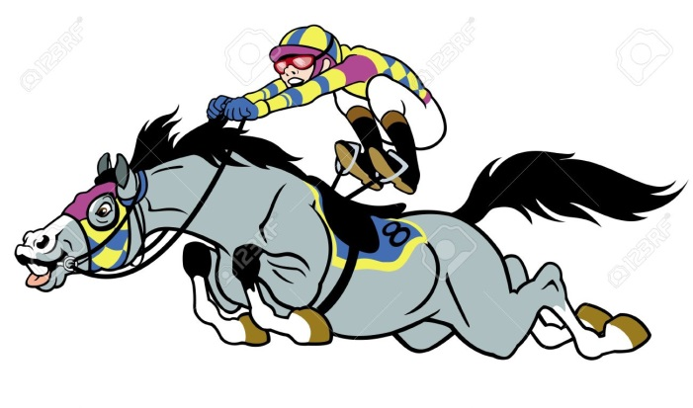
NAME OF HORSE _____________________

YEAR HORSE WON KENTUCKY DERBY _____
BIRTHPLACE _____________________
COLOR ____________________
NUMBER OF STARTS ______
NUMBER OF WINS ______

ONE INTERESTING FACT ________________________________________________________________________________________________________________________________________________________________________________________________________________

